**The Evolution of Money**

* Money solves the basic problems of a barter economy, especially the “double-coincidence of wants”. It should play three roles:

1. Medium of Exchange:

* Money solves the need for a “double coincidence of wants” before exchange takes place.
* Requires everyone to accept money: “Trust” / “Confidence”.

1. Unit of Account:

* Money should also be used to measure the value of goods (divisible)
* Makes sense if also the medium of exchange

1. Store of Value:

* Money should be able to hold wealth from one period to the next (doesn’t disintegrate)
* Throughout history many things, from rocks to rum, have been used as money, to varying success:
* Rai Stones, Micronesia, ~500-1900 CE
* Shell, Global, ~7,00 BCE-1900s CE
* Rum, Australia, 1788-1812
* Gold has been used as currency at least far back as ~3000 BCE in Egypt. It has no inherent value, it all comes down to trust.
* Oldest coin: Electrum Stater of Lydia, 800-700 BCE
* Egypt, 1324
* Spain 16th Century
* Paper money originated because it was easier to carry than gold (better medium of exchange). For centuries it was backed by physical gold.
* The Bank of England originally backed all notes and coins with gold (the “gold standard”), but abandoned this during the great depression.
* The fundamental point about money: It has no inherent value. Like much of macroeconomics it is all about a “feedback loop”:
* The value of money stems from its ability to simplify transactions --- Solves the “double coincidence of wants” problem
* It can only perform this function if sellers trust that other people will also accept it. A network equilibrium.
* If people believe that money has value, then it has value. It is a self-fulfilling prophecy based on people’s beliefs:

1. Consumer confidence affects aggregate demand.
2. In 1993 George Soros convinced people that the UK pound was overvalued.
3. De Beers convinced people that diamonds are very valuable.

* The Bank of England could only abandon the gold standard because people already believed that money had value.
* Money doesn’t need to be issued by the government if it is trusted, but government support helps.
* During the UK Civil War (17th Century) – traders would issue their own tokens as currency, because the government couldn’t spare the metal.
* Bitcoin is like a “stateless currency” with a monetary regime similar to a gold standard:
* Created from nothing
* Only has value if people believe that others will accept it
* Similar to gold as Bitcoin supply constrained by algorithmic “mining” and it is treated like and asset – buy and hold.
* Exchange rate with other currencies varies.
* These beliefs can be destroyed, like when hyperinflation destroyed beliefs in the value of Zimbabwe’s currency, and it was replaced with the USD

**Types of money in the modern economy**

* Modern money is a set of IOUs between three groups in the economy: the central bank, commercial banks and consumers:

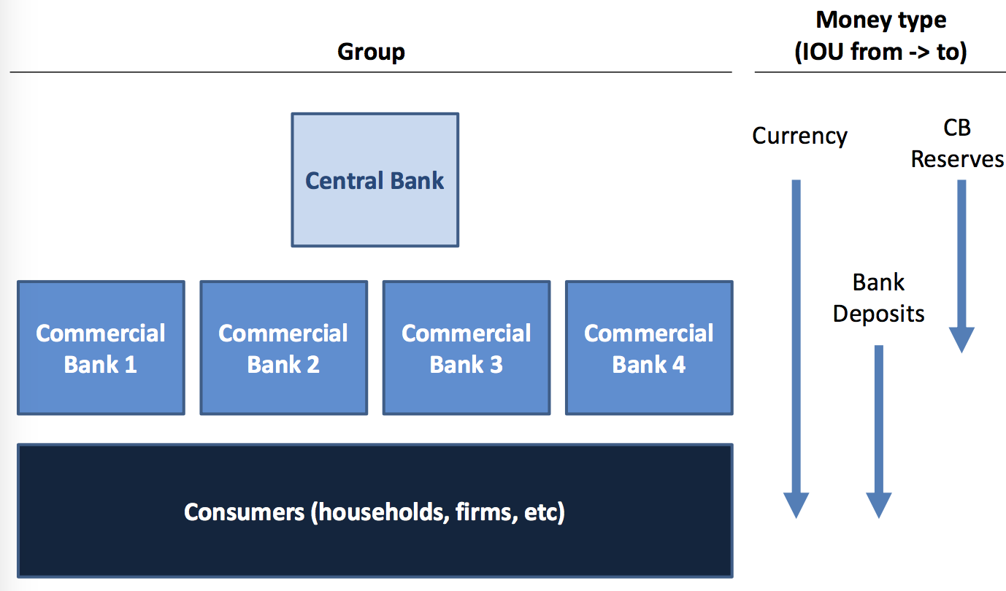

* In a modern economy bank deposits make up the vast majority of money held by households
* Notes and coins are IOUs from the central bank to households (households claim over central bank assets).
* Bank deposits are IOUs from commercial banks to consumers
* When a consumer deposits currency in their bank account they exchange an IOU fro the central bank for an IOU from the commercial bank
* The IOU is a form of an electronic number on a screen
* Bank deposits are held because they are safer and more convenient than cash, and they earn interest
* Technology is increasing the demand for bank deposits relative to cash
* Central Bank reserves are IOUs from the central bank to commercial banks. They are used to settle transactions between banks:
* CB reserves are IOUs from the central bank, They are electronic numbers on a screen, but are equivaleng to banks holding cash in a vault
* Everyday people buy and sell things from one another,

if buyer and seller from the same bank --- cancel out

if from different banks --- settle at the end of day electronically using reserves

* Commercial banks hold reserves to meet withdrawals --- don’t need 100% of deposits held in reserves (hard currency). This is called “fractional reserve” banking.
* Fractional reserve banking:
* if commercial banks had to hold all their cash deposits in a vault --- 100% reserves
* if commercial banks are only required to hold 10% in reserves, the rest can be loaned out for higher interest

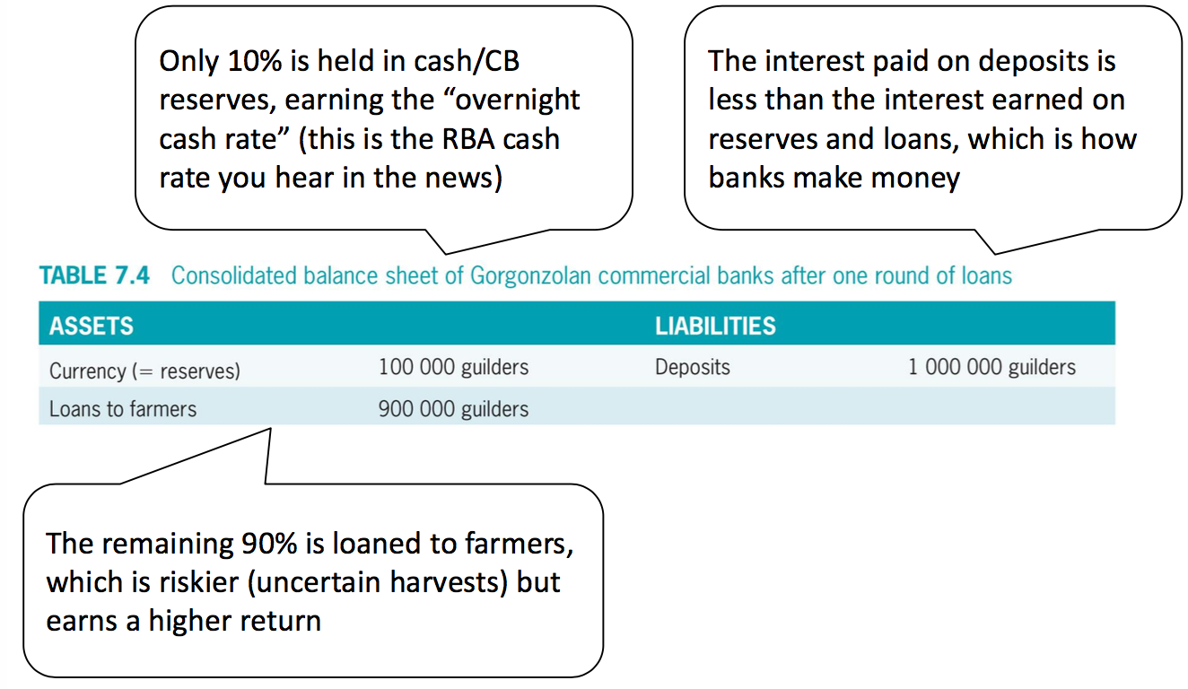

* In equilibrium, the 90% loaned to farmers is spent, so ends up back in banks as more deposits, which can be loaned:

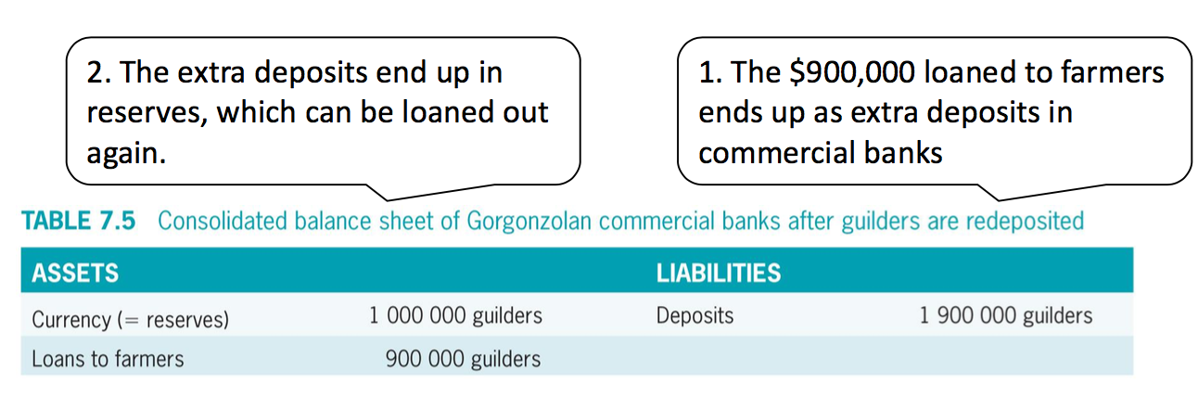

* The ultimate effect that the $1,000,000 in currency ends up as reserves, and multiples up to $10,000,000 in deposits in equilibrium. (However, if some farmers hide cash under their bed, then not everything ends up as bank deposits, and the “multiplier” effect of fractional reserves on the money supply is less
* Reserve requirements for commercial banks affects the money supply:

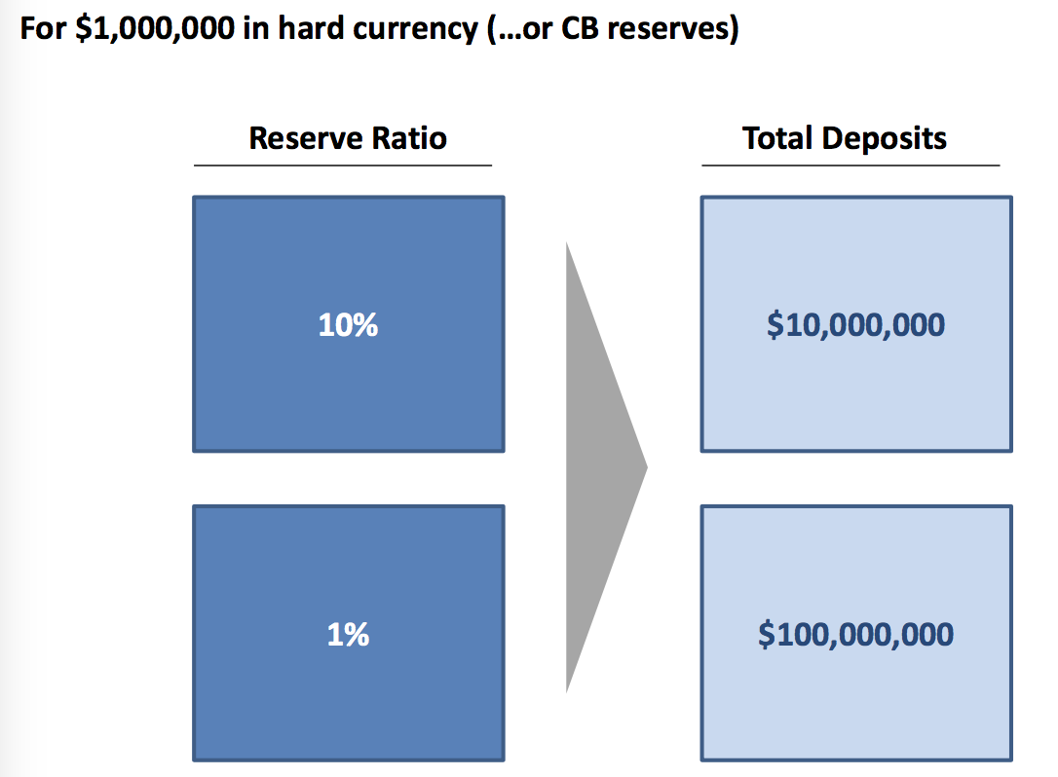

* The money supply changes very frequently, while reserve requirements change very infrequently.
* The central bank creates and destroys money by changing the interest rate --- this causes commercial banks to change their lending
* “Unconventional policy” might include changing reserve requirements in the future
* “Macro-prudential policy”: changing reserve requirements with the business cycle. The Bank of England and RBA are considering this.
* Important if interest rates don’t work (zero lower bound)
* Sometimes bank reserves are not enough to meet withdrawals, such as during a “bank run” – when trust in the banks runs out:

Eg. Northern Rock was a UK bank that suffered a bank run in 2007

* Needed to approach the Central Bank for a loan to meet withdrawals
* Led to more withdrawals: self-fulfilling prophecy
* Taken over by the UK gov’t in 2008 and bought by Virgin Money in 2012

**How is money created in the modern economy?**

* The central bank controls how many notes and coins are created in the mint
* Commercial bank deposits, like all money, are IOUs, and so can be created at will by the bank. Banks create money out of nothing. (It’s actually created out of the trust that people place in their ability to redeem bank deposits…)

Eg. When a bank makes a new home loan, it just adds electronic numbers to the borrower’s account. This increases total deposits.

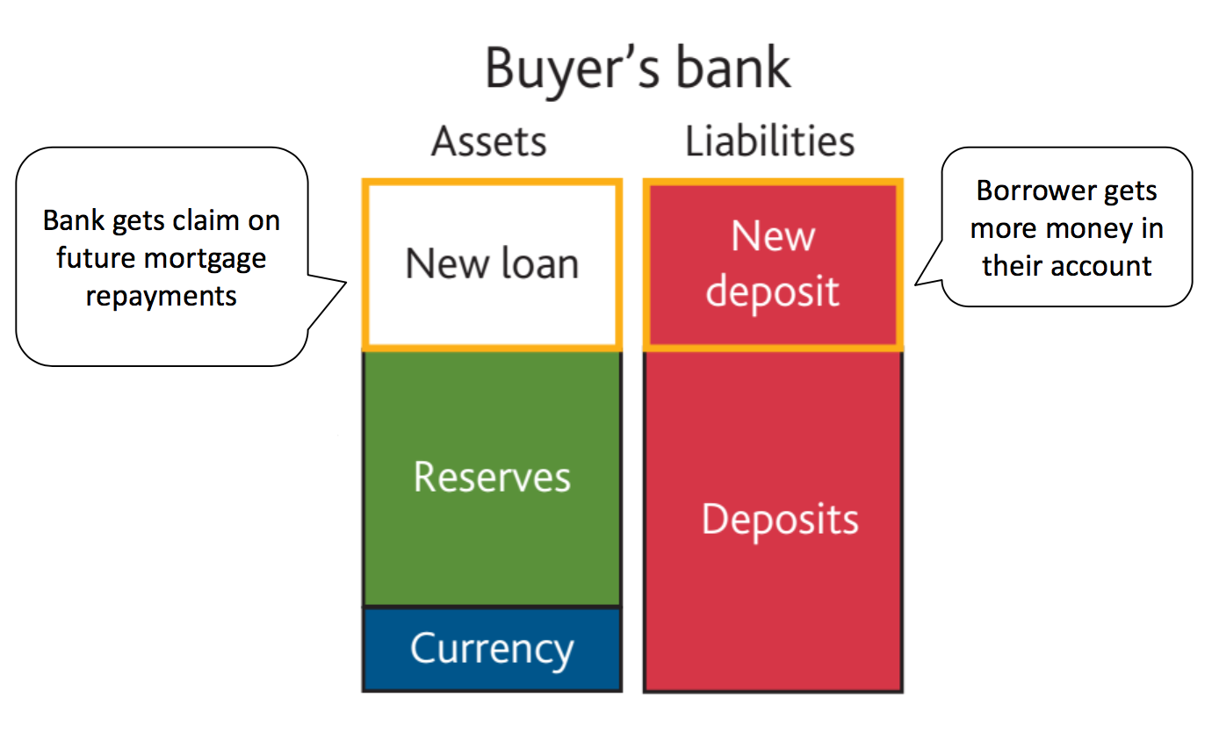

The borrower will then withdraw the electronic numbers as cash (reserves) and give it to the house seller, who deposits with their bank:

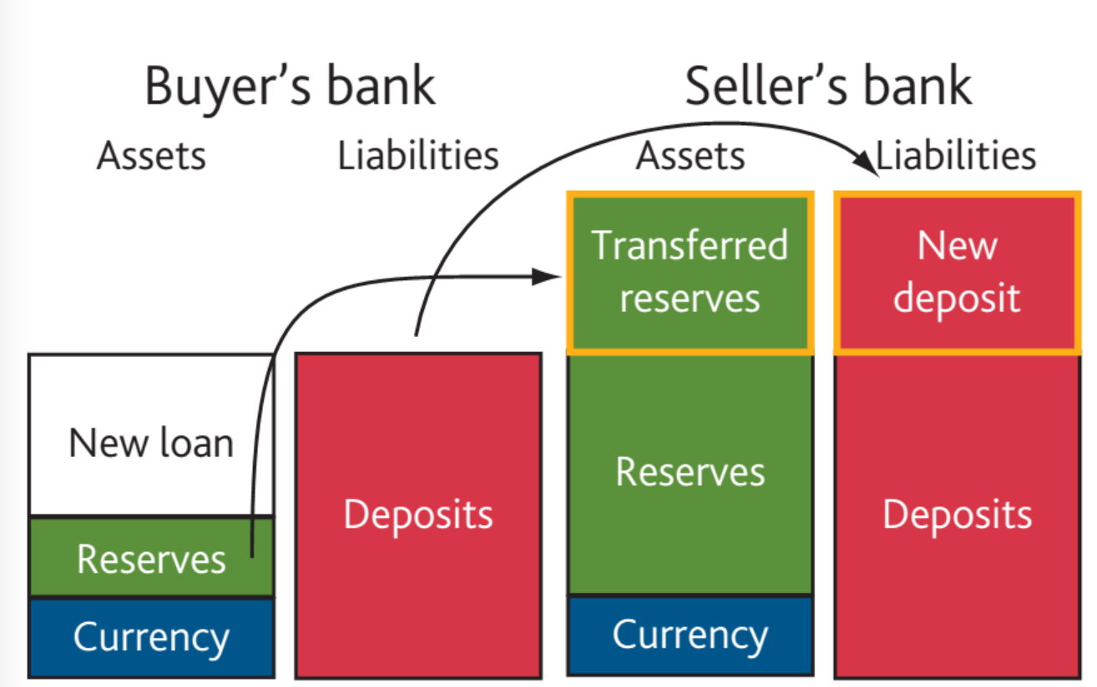

if the house buyer and seller have the same bank, the bank’s balance sheet will just get bigger:

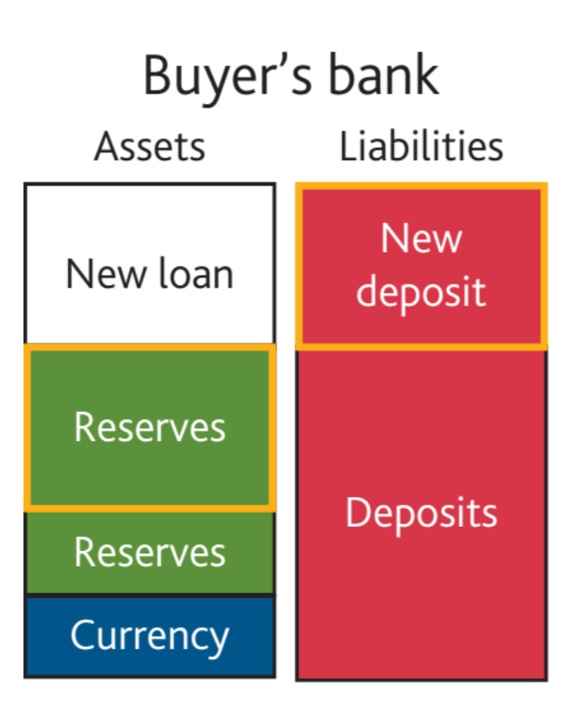

Banks don’t lend money infinitely because they need to make a profit, which is determined by interest on reserves.

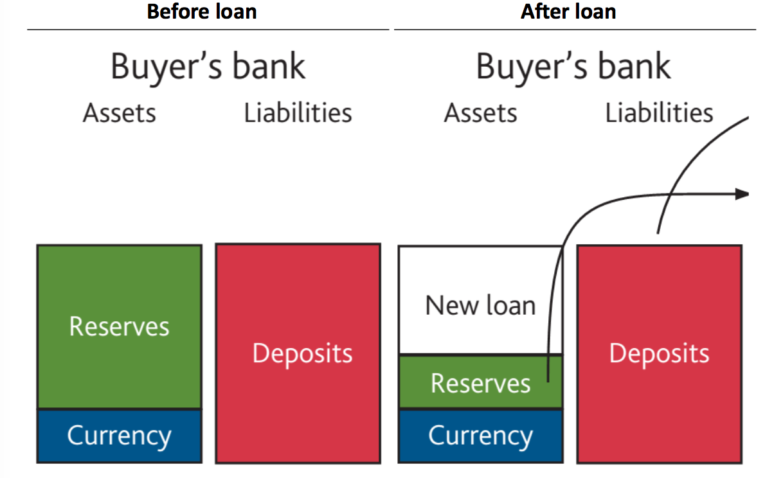

The bank had to settle the transaction in cash (reserve), so it has less. To get more it needs to borrow from the CB at the overnight cash rate (1.5% p.a. in Australia)

* The three limits on banks creating money are: the cash rate, capital requirements and consumers destroying money:

1. Cash rate:

* Banks settle loans using cash/reserves
* The opportunity cost of fewer reserves is the “overnight cash rate”

Loan must earn a risk-adjusted return > cash rate

* The Central Bank sets the cash rate monthly

1. Capital Requirements:

* Bank have limits on the amount of deposits they can have relative to reserves
* This is usually not the binding constraint

1. Households destroy money:

* If a household borrows a loan then money is created.
* If a household repays a loan then money is destroyed.

Eg. Buying a home from someone who has a mortgage

Rising house prices, less money destroyed, higher money supply: feedback loop.

* A deleveraging reduces the amount of debt (loans) in the economy, and therefore the amount of bank deposits (money)
* The decision process for a commercial bank to make a loan:

1. Borrower approaches bank: loans typically initiated by borrowers who sees a need for investment
2. Bank evaluates profitability: Bank checks: interest earned, probability of receiving it, cost of financing by having fewer reserves
3. Bank makes loan: adds electronic numbers to borrower’s account (L) and creates claim on the borrower’s asset (A)
4. Bank settles loan: transfers reserves to bank of person selling house/machine/etc
5. Bank requests reserves from CB: Requests more reserves if necessary to meet future deposits (exchange reserves for other assets)

* Reserves are created when the CB buys assets from banks or the gov’t, as with Quantitative Easing, and destroyed when assets are sold
* So, money is created by banks making new loans. Not by multiplying deposits, nor by the CB multiplying up reserves.
* How money is not created:

1. Fractional reserve banking

Because: Banks don’t need to gather more deposits before they make a loan

Saving more doesn’t increase loanable funds (if it is spent it will end up in a bank deposit – paradox of Thrift)

1. Fractional reserve central bank

Because: Banks don’t need to draw down their central bank reserves to make a loan (only if can’t finance with new deposits)